External Affairs Manager

Job purpose:

To develop and implement a comprehensive, high-quality plan for engagement and relationship management with key strategic stakeholders, business groups and with the largest 50 in-house legal teams.

Key Accountabilities:

- Work with colleagues and senior leaders across the Law Society to support the shaping and delivery of the in-house ‘member offer’, whilst also taking responsibility for leading elements of the offer for the largest 50 in-house teams.

- Identify and apply member and market insights to ensure the Law Society continues to understand its key stakeholder and large in-house member interests, and can respond appropriately.

- Ensure close collaborative working with a broad range of colleagues to make connections with stakeholders managed through other teams, e.g., local law societies, politicians/policy makers, international stakeholders, D&I networks.

- Identify and engage with a wider stakeholder community engaged in key issues of interest for large inhouse / business sector – these could include ‘new law’ enterprises, charitable and social initiatives, city and business networks.

- Develop strong personal relationships with the most senior individuals in stakeholder organisations, including Senior and Managing Partners, General Counsel, Chairmen, Directors, CIO’s and CEO’s, introducing them to others in TLS and facilitating their participation in TLS strategic activities.

- Develop and communicate (internally and externally) a thorough understanding of the structure and running of the Law Society and of strategically important external bodies.

- Play a central role in activities intended to promote London as a global legal hub and to raise awareness of the contribution that leading English and Welsh law firms make to the legal profession domestically and internationally.

- Devise and play a central role in activities designed to demonstrate the value and impact of external engagement to the Law Society, facilitated by building and maintaining strong internal relationships across organisation at all levels, including Office Holders and Executive Leadership.

- Make a key contribution to efforts across the Law Society designed to promote stakeholder engagement, developing strong internal relationships to ensure close and effective working with key teams including Member Communications, Member Engagement, Policy and PA.

- Oversee and manage an account management approach to our large firms and large in-house member segments, ensuring we make best use of CRM, reporting and data to drive wider and deeper engagement with these groups.

- Project manage Roundtables, Webinars, Podcasts and contributions from the Law Society at external meetings and events - ensuring these are delivered in line with an agreed business plan and relevant wider resources.

- Respond to external developments by creating opportunities for the Law Society to convene stakeholders and add value to strategically important policy and professional issues.

- Initiate and deliver projects, including those delivered in partnership with other agencies or organisations.

- Lead on the planning and delivery of events, prepare and deliver presentations.

- Commission, follow up and present relevant work to support strategic stakeholder activities.

- Deal independently with substantial incoming communications, initiate action and deal with these on own initiative, including confidential information.

- Deliver achievable and ambitious plans for the External Affairs function as part of the annual business planning process - monitoring and providing effective and clear reporting on delivery.

- Oversee the work of an External Affairs Executive within the External Affairs team, ensuring speed of response and quality of support reflects the high expectations of these key stakeholder groups.
Knowledge, skills and experience

Essential

- Critical thinking at degree level

- Experience of working on substantial projects with senior executives and Board Members, an ability to develop and maintain close working relationships with them and their teams

- Excellent project management, communication, presentation skills, report writing and drafting skills

- Ability to conduct substantial research, identify the key information/messages and be able to effectively communicate these

- High level of initiative, problem solving and decision-making skills

- Excellent organisation skills and attention to detail

- Excellent ability to build, develop and maintain working relationships with other team members and with senior internal and external stakeholders

- Excellent analytical, computer and database skills

- Ability to multitask and work independently under pressure

- Ability to project a positive and confident image of TLS

- A good working knowledge of other cultures and business practices

- Ability to exercise sound judgement across a range of complex and diverse issues

- Experience of overseeing the work of others to ensure work is delivered on time and to a high standard

- Strong influencing and negotiating skills

- A proactive, action orientated and delivery focused approach

Planning & Organising  - Able to work autonomously to complete work on time and to a high standard  - Evaluate and apply judgement using own initiative, referring to the Director or other senior colleagues where necessary.  - Develop a thorough understanding of TLS organisational relationships and processes  - The role holder will be required to work effectively under pressure, and to deadlines | Organisation Chart  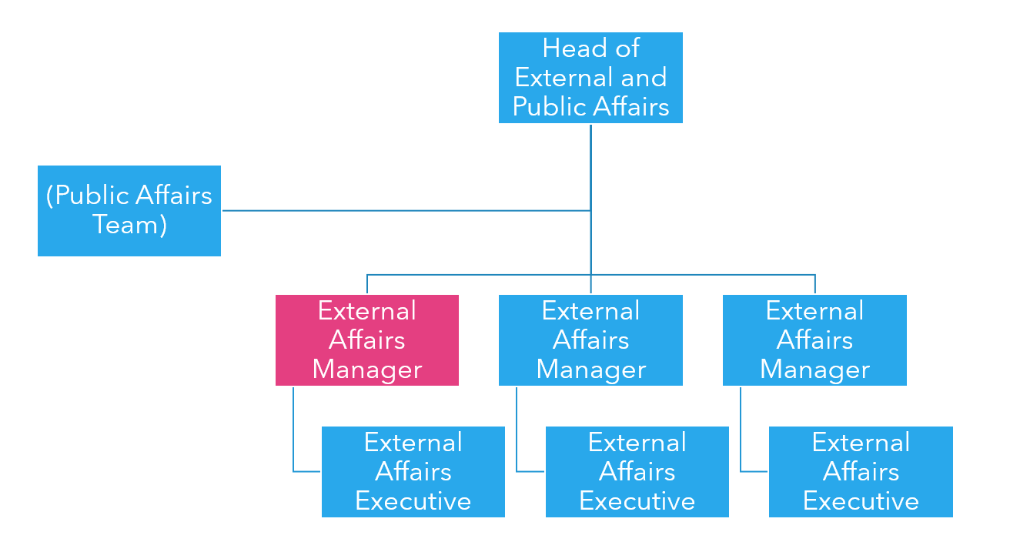
Dimensions

Operating environment

- Together with key senior colleagues from across the Law Society, the role holder will be responsible for highly visible areas of the work, which means the post holder is required to function effectively under pressure and be able to deal with the conflicting demands of senior stakeholders both within and outside the Law Society.

- Standard hours will be 9.00am – 5.00pm. However, at times the role holder will be required to work flexibly to meet the demands of busy schedules and participate in events.

- Daily contact with colleagues at all levels across the Law Society and with a range of external stakeholders, with Council members and Office holders

Financial responsibility

None
Location

Hybrid working to include working from 113 Chancery Lane

